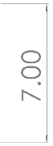
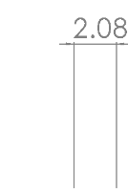
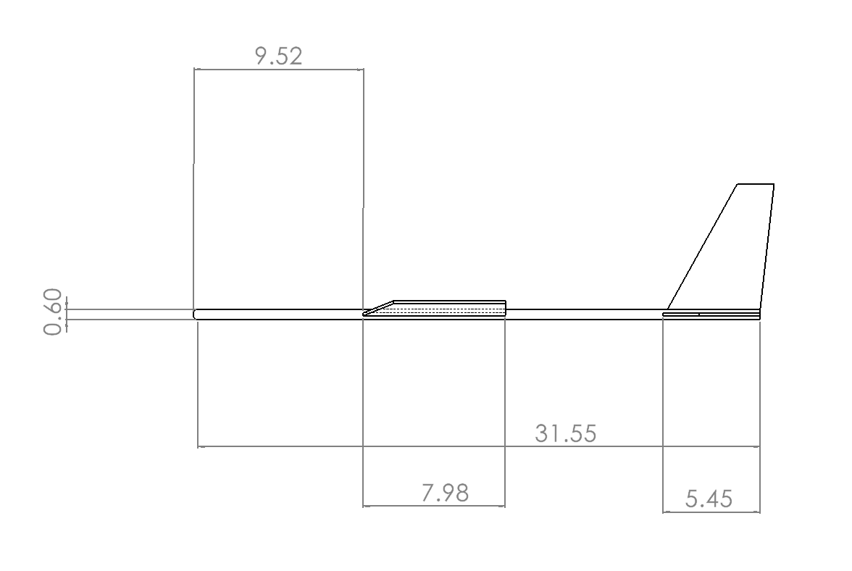
TOP VIEW
Vertical Wing Root chord
Vertical Wing tip chord
Fuselage Length
Wing Root chord
Wing Location
Wing Tip chord
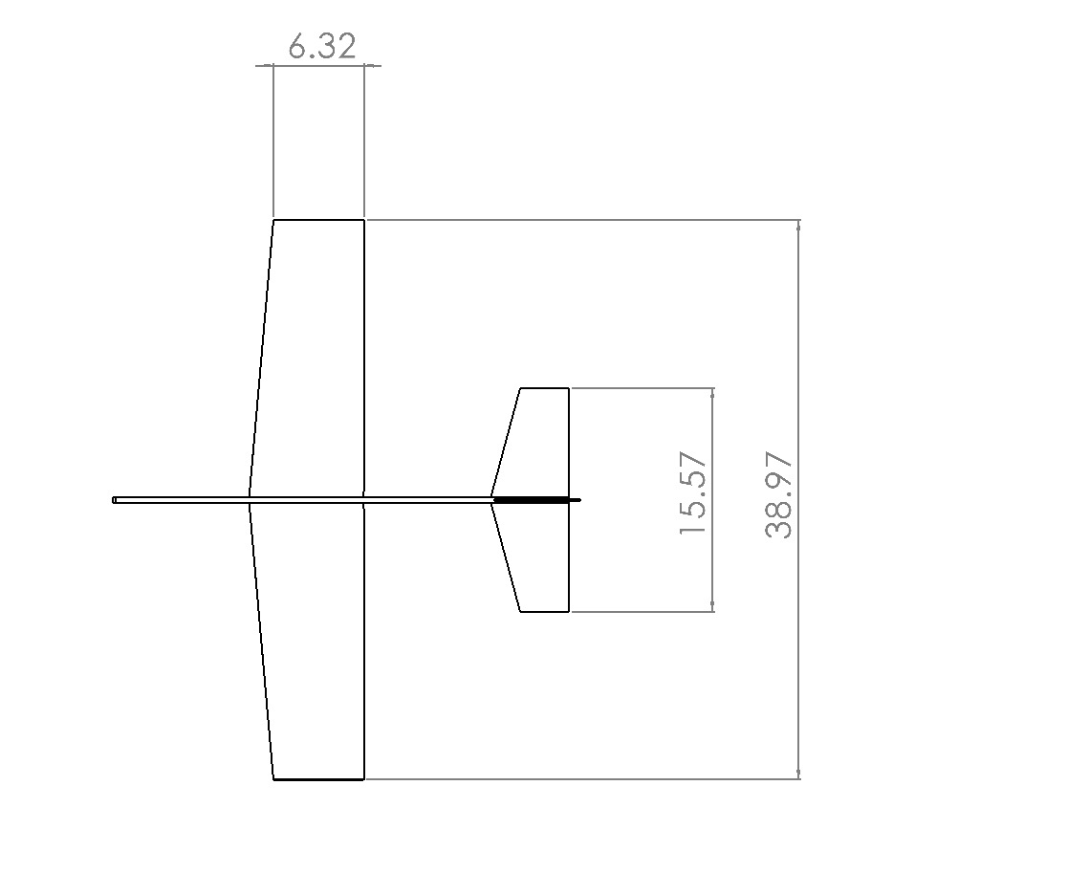

Horizontal tail span

Wing Span

FRONT VIEW

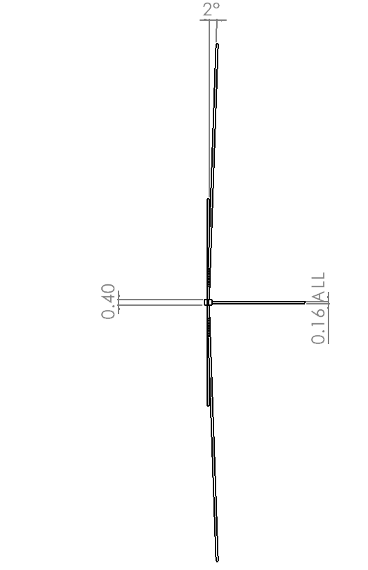

SIDE VIEW

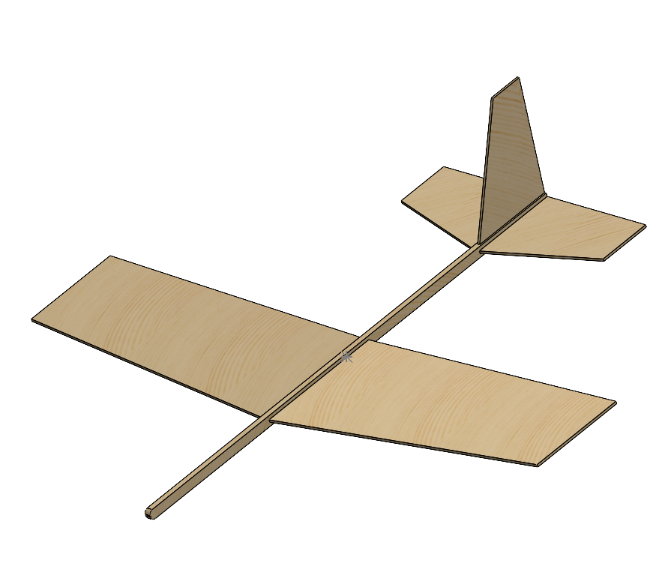

GLIDER MODEL IN SOLIDWORKS

Sketch and Dimensions:
Design Rationale:
Throughout the design process thus far, I have been using the Aery32 software to iterate through several small design changes, which have compounded to significant improvements over time. My design initially started as a rectangular glider to get a good baseline of what could fly before making advanced geometry modifications. Through these changes, the wings now span 39 cm with an 8cm root chord, which resulted in an aspect ratio of 5.45. This 5-6 aspect-ratio range optimizes efficiency while reducing drag, so sitting comfortably in the middle of this range after changing the leading-edge sweep was a great balance to maintain. The wing is currently positioned at 9.5 cm back from the nose of the glider to place the center of gravity 25-33% from the average leading edge of the wing to the back of the wing, which is great for stable flight. The fuselage length was found to be optimal at 31.8 cm, providing enough effectiveness to the vertical and horizontal stabilizers while being conscious of the weight.

Throughout multiple iterations, the primary adjustments I made to increase stability, and by extension the Aery Evaluation Number, were finding the right balance for nose mass, tail sizing, and planform geometry. Specifically, I cut back the nose mass from my initial guess of 10 g by 500%, and I moved the vertical and horizontal stabilizers as far aft as possible. Additionally, introducing a taper combined with a slight sweep to the wing and tail surfaces seemed to improve the aerodynamics, and the added complexity wouldn’t change the fact that we could laser cut the components. Lastly, I reduced the cross-sectional dimensions of the fuselage significantly to reduce the mass. This culminated in an Aery Evaluation Number of 194. Considering “just under 200” is the recommendation for the most distance-efficient gliding, I believe this to be a strong baseline for our first real-world iteration.

